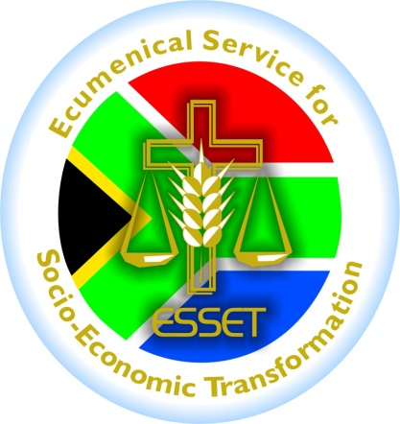
6th Floor, Khotso House, 62 Marshall Street, Johannesburg, 2001
P.O Box 62098, Marshalltown, 2107
Tel: 011 833 1190, Fax: 011 833 1076, info@esset.org.za

MEDIA STATEMENT

Date: 03/05/2012
Re : ENOUGH IS ENOUGH with metro police brutality on informal traders
The Ecumenical Service for Socio-Economic Transformation (ESSET) condemns in the strongest possible terms the punching and kicking of an informal trader, Andries Ndlovu by four uniformed metro police officers in Ivory Park, Midrand. According to Sunday Times, Ndlovu was beaten on Freedom Day after he asked the metro police officers why they were beating another informal trader, a 60-year-old welder who demanded a receipt or notice when his goods were impounded by the same metro police.
The attack which was publicised widely by various media houses is just but a tip of the iceberg of the harassment experienced by informal traders in many townships, cities and street corners at the hands on the metro police. The unwarranted beating of Ndlovu confirms the stories told by the traders in the recent consultations held with traders in the past week. Traders spoke of excessive harassment and maltreatment by law enforcers. They did not only cry of stock confiscation but also of the manner in which this was done. They reported of how the metro police, as was the case in the Ndlovu incident, viciously beat up some traders whilst taking their goods for themselves. In our books, these actions should be named for what they are: theft from the poor who are trying to make an honest living for themselves. Even as we issue this statement, we have received further reports of stock impoundment and harassment from informal traders that we work with in Lenasia. In our view, the treatment of informal traders by our democratic government is a display and a reinforcement of the old apartheid tactics, which restricted informal traders and other poor people from the cities.
The incidents of police brutality against the poor, which took place at the dawn of the Freedom Day and Workers Day celebrations, are an embarrassment to the nation. ESSET, as an ecumenical organisation that has been accompanying the struggle of informal traders, is calling on all South Africans, Churches and social justice practitioners to stand in solidarity with the informal traders and other formations of the poor and denounce the on-going injustices meted against them as witnessed by the police brutality on Andries Ndlovu. In response to this call, the Anglican Archbishop of Cape Town, Rev Dr. Thabo Makgoba suggests a solidarity march to show support against such injustices. May his pounding agitate all of us to jointly say ENOUGH IS ENOUGH with the metro police brutality on informal traders and the poor!
This statement is endorsed by ESSET; Mike More, the Chairperson of Gauteng Informal Development Association (GIDA); Sipho Thwala, Co-ordinator of SADC Informal Traders Network; Rev Dr. Prince Dibeela, General Secretary of the United Congregational Church of Southern Africa (UCCSA); Archbishop Thabo Makgoba, Anglican Archbishop of Cape Town and Metropolitan of the Anglican Church of Southern Africa; and Rev Mautji Pataki, Secretary General of the South African Council of Churches.

